Hi, during the testing of the application following observations appeared :

1. **Transactions Missing from Reports**: Some transactions, like "Personnel Expenses" and "Subscribed but Unpaid Capital," do not appear in the Balance Sheet or Income Statement even though they were uploaded successfully. This means the logic is not processing all transactions correctly.
2. **Errors in Calculation**: For certain categories, such as "Depreciation," the system does not handle them correctly. For example, instead of showing a reduction in the value of "Property, Plant, and Equipment," it tries to assign the value to a non-existent account.
3. **General Ledger Issues**: The General Ledger is not showing the correct totals for some categories. Additionally, there is no option to download it, which is an essential feature.
4. **Missing Confirmation for New Clients**: When registering a new client, there is no confirmation request (e.g., email confirmation), which can be a security issue.
5. **Application Name:**

Pls., update the application's name from "Finance Manager" to "AI CFO Assistant" across all visible sections, including the header.

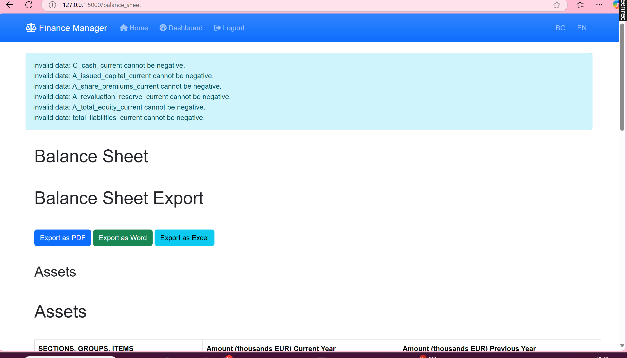

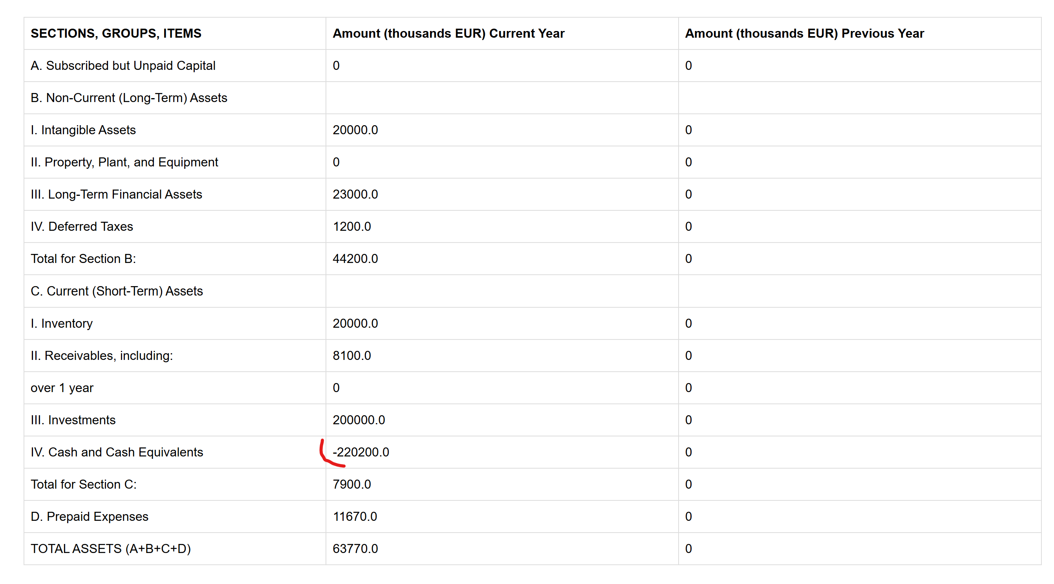

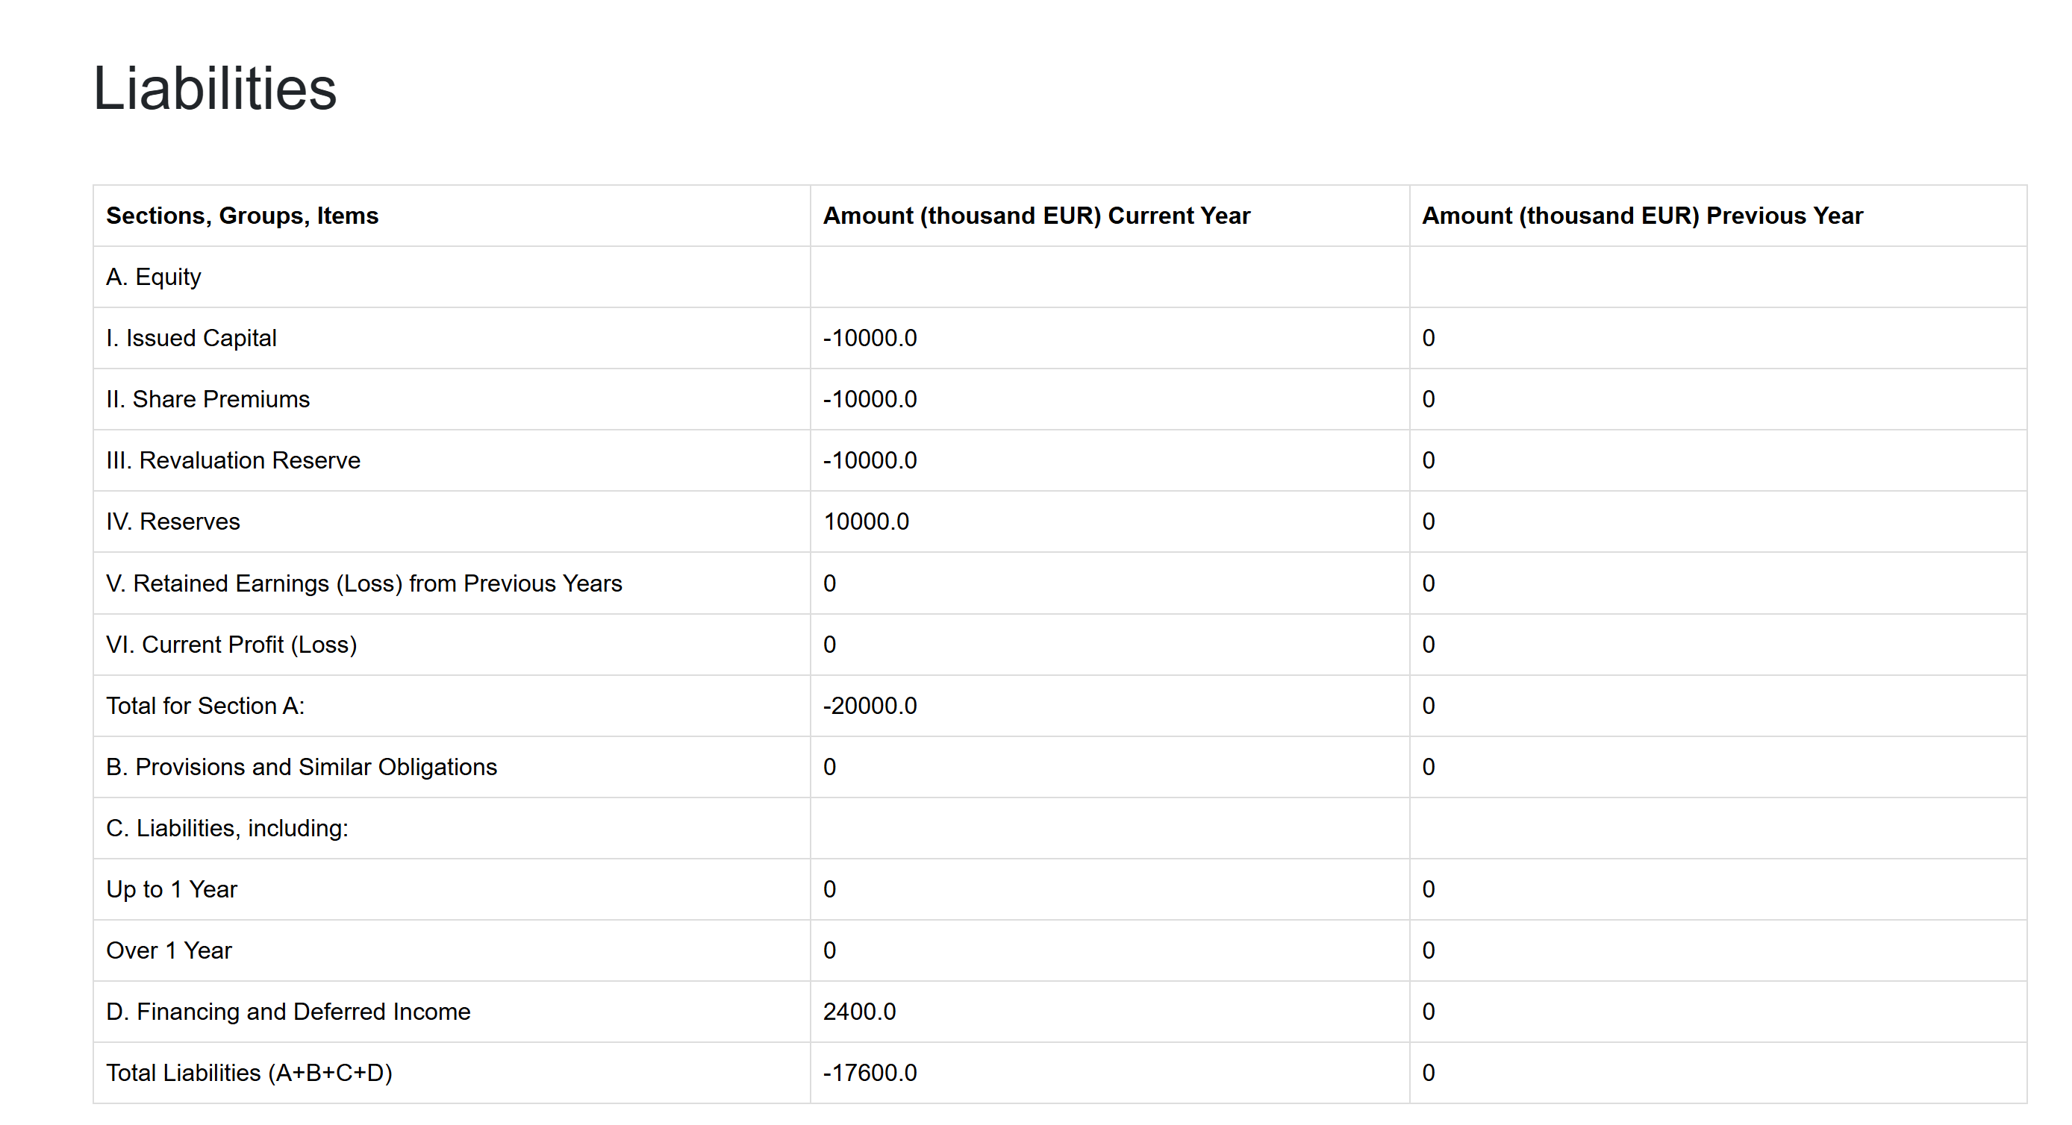

**Technical Instructions for Code Fixes**

Technical Instructions for Code Fixes

1. **Implement Validation Logic for Balance Sheet Categories**

- **Problem:** The current code does not validate or properly update all categories in the Balance Sheet. For example, **Liabilities** and some **Equity** categories are not reflected correctly.

- **Solution:** Introduce a comprehensive validation logic to ensure every category in the Balance Sheet is updated correctly.

**Code Suggestion:**

```python

def update_balance_sheet(category, amount):

if category not in balance_sheet:

raise ValueError(f"Invalid category: {category}")

balance_sheet[category] += amount

if balance_sheet[category] < 0:

raise ValueError(f"{category} cannot have a negative balance.")

```

2. **Add Comprehensive Logic for Income Statement**

- **Problem:** Certain transactions, such as **Personnel Expenses**, are not reflected properly in the Income Statement.

- **Solution:** Ensure all income and expense categories are correctly mapped and updated in the Income Statement.

**Code Suggestion:**

```python

def update_income_statement(category, amount):

if category not in income_statement:

raise ValueError(f"Invalid category: {category}")

income_statement[category] += amount

```

3. **Handle Depreciation Correctly**

- **Problem:** Depreciation logic is currently incomplete. Depreciation should directly reduce the balance of **Property, Plant, and Equipment (PPE)** rather than using an **Accumulated Depreciation** account.

- **Solution:** Update depreciation transactions to:

- **Debit:** Depreciation Expenses (Income Statement).

- **Credit:** Property, Plant, and Equipment (Balance Sheet).

**Code Suggestion:**

```python

if transaction.category == "Depreciation":

update_balance_sheet("Property, Plant, and Equipment", -transaction.amount)

update_income_statement("Depreciation Expenses", transaction.amount)

```

4. **Fix Imbalances in General Ledger**

- **Problem:** Certain categories, like **Supplier Services**, show imbalances between debit and credit totals.

- **Solution:** Add validation logic in the General Ledger to ensure that all debit entries have corresponding credit entries.

**Code Suggestion:**

```python

def validate_ledger_entries():

for entry in ledger:

if entry.total_debit != entry.total_credit:

raise ValueError(f"Imbalance detected in category: {entry.category}")

```

5. **Export General Ledger as Excel**

- **Request:** Add a button to download the General Ledger as an Excel file.

- **Solution:** Use a library like `pandas` to export the ledger to an Excel file.

**Code Suggestion:**

```python

@app.route('/download_general_ledger')

def download_general_ledger():

ledger_data = get_general_ledger_data() # Fetch ledger data

df = pd.DataFrame(ledger_data)

output = io.BytesIO()

with pd.ExcelWriter(output, engine='xlsxwriter') as writer:

df.to_excel(writer, index=False, sheet_name='General Ledger')

output.seek(0)

return send_file(output, mimetype='application/vnd.openxmlformats-officedocument.spreadsheetml.sheet', as_attachment=True, download_name='General_Ledger.xlsx')

```

Add a button on the General Ledger page:

```html

<a href="/download_general_ledger" class="btn btn-primary">Download as Excel</a>

```

6. **Add Confirmation for New Client Registration**

- **Problem:** There is no confirmation request when a new client registers.

- **Solution:** Add a confirmation step to the registration process.

**Code Suggestion:**

- Send a confirmation email after registration:

```python

def send_confirmation_email(user_email):

confirmation_link = generate_confirmation_link(user_email)

send_email(

to=user_email,

subject="Confirm Your Registration",

body=f"Please confirm your registration by clicking this link: {confirmation_link}"

)

```

- Update the registration route:

```python

@app.route('/register', methods=['POST'])

def register():

# Existing registration logic

send_confirmation_email(user_email)

return "Please check your email to confirm your registration."

```

7. **Improve Error Handling and Reporting**

- **Problem:** Error messages like "Invalid Data" are unclear.

- **Solution:** Add specific error messages that indicate what went wrong.

**Example:**

```python

if balance_sheet["Cash"] < 0:

raise ValueError("Cash balance cannot be negative. Please review transactions.")

```

8. **Rename Application to "AI CFO Assistant"**

- **Request:** Update the name of the application from "Finance Manager" to "AI CFO Assistant" in all parts of the application.

- **Solution:** Locate and update all instances of the application name in the codebase, including:

- Navigation bar:

```html

<div class="navbar-brand">AI CFO Assistant</div>

```

- Page titles and headers:

```html

<title>AI CFO Assistant</title>

<h1>Welcome to AI CFO Assistant</h1>

```

- Emails, alerts, and any other references in the code.

Summary of Changes Needed:

1. Add validation logic for all Balance Sheet categories to prevent negative balances and ensure accurate updates.

2. Ensure all Income Statement categories, such as **Personnel Expenses**, are properly reflected.

3. Update depreciation logic to directly reduce **Property, Plant, and Equipment**.

4. Validate debit and credit totals in the General Ledger to prevent imbalances.

5. Implement functionality to export the General Ledger as an Excel file.

6. Add confirmation email functionality for new client registrations.

7. Improve error messages to be specific and user-friendly.

8. Rename the application to "AI CFO Assistant."